018 Gulp - transpile typescript

Gulp Kata List – Blog Page

[Gulp Kata List on GitHub](https://github.com/robertdunaway/katas-gulp)

# Duration

5 minutes

# Brief

Transpile typescript to JavaScript and optimize and map the files.

### For More Information

BING/GOOGLE: “Gulp typescript”

Book: <http://www.amazon.com/Gulp-Quick-guide-getting-running/dp/151468960X>

# Instructions

Get tutorial folder or the entire katas-angular2 repo.

Open the [before/*.sln] file and execute the kata.

Feel free to execute this kata multiple times because repetition creates motor memory.

# Github

* Before (start kata with this)
  + https://github.com/robertdunaway/katas-gulp/tree/master/018%20Gulp%20-%20transpile%20typescript/before
* After
  + https://github.com/robertdunaway/katas-gulp/tree/master/018%20Gulp%20-%20transpile%20typescript/after

# Kata

We’ve added a new folder named “ts” with TypeScript files. Transpile these *.ts files to JavaScript, optimize them, and map them.

# Review

Install the required plugins.

npm install gulp-typescript --save-dev

npm install gulp-uglify --save-dev

Update references

, ts = require('gulp-typescript')

, uglify = require('gulp-uglify');

Add the new task named tscompile

gulp.task('tscompile', function () {

return gulp.src(['./wwwroot/**/*.ts', '!wwwroot/lib/**/*.*'])

.pipe(sourcemaps.init())

.pipe(ts({

target: 'ES5',

declarationFiles: false,

noExternalResolve: true

}))

.pipe(rename({ extname: '.js' }))

.pipe(uglify())

.pipe(sourcemaps.write('./'))

.pipe(gulp.dest('wwwroot/./'));

});

Wire the new tscompile task into the default task.

gulp.task('default', function () {

runSequence('clean-wwwroot', 'copy-to-wwwroot', 'tscompile');

});

Run the default task

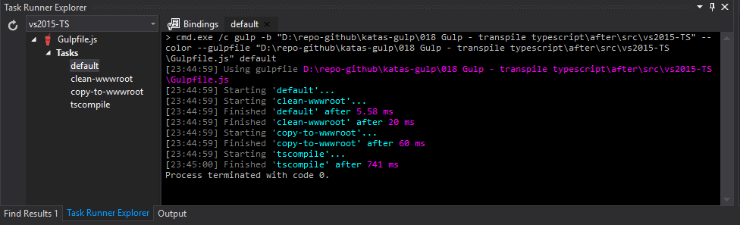

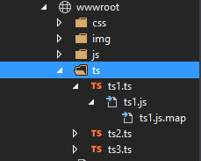

# Next

Take a few minutes and imagine more examples.